PRESS RELEASE: FOR IMMEDIATE RELEASE

Cool Bugs UK

A UK charity is launching a campaign to save our bugs.

Do you remember a time when a car journey meant lots of squashed insects on the windscreen? Not anymore, as the number of British insects has plummeted since the 1960s. Almost half of Britain’s natural biodiversity has already disappeared.
Animals like this shrill carder bee were once common in Britain but now are endangered.
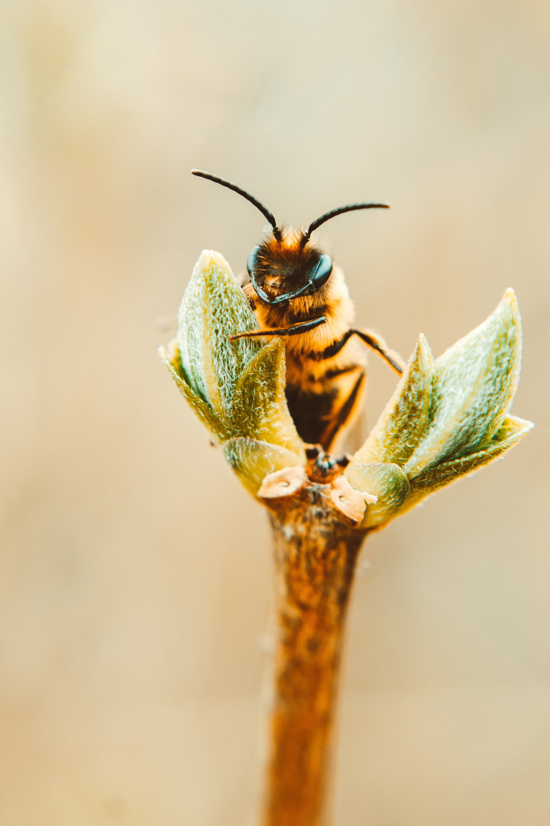
WHY NOW?
We have seen long periods of rain and flooding and dry, hot summers. Climate change is helping to reduce the number of UK bugs, including spiders, bees, snails, and spiders. The number of butterflies has plummeted to a record low. Thirteen bee species have gone extinct in the UK, with more threatened with extinction. The fall in the number of bugs has led to a reduction in birds. Grey partridges, for example, depend on sawflies for food, and many chicks have died as there are not enough sawflies.
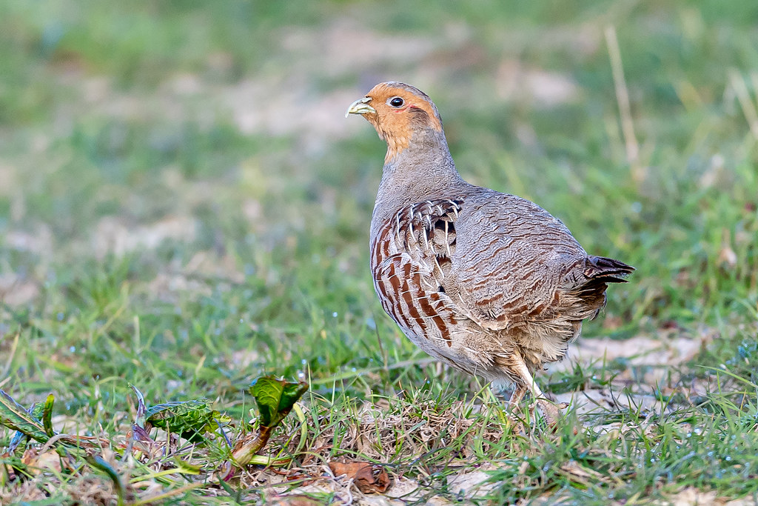
And yet, this destruction receives little public attention. We all need to reverse this catastrophic decline and help protect our UK bugs.
Campaign
The Frozen Ark has launched a Crowdfunder campaign to raise £20,000 funding to pay for staff and volunteers to collect samples of rare UK invertebrates.
https://www.avivacommunityfund.co.uk/cool-bugs-uk?
The Frozen Ark
The Frozen Ark collects and cryopreserves DNA and cell samples of endangered animals. DNA and cells can guide the reintroduction of missing genetic diversity in wildlife populations, prevent inbreeding, and identify, introduce, or preserve characteristics that can help a species adapt to ongoing climate change.
The Frozen Ark is a small charity with two part-time staff and many volunteers. All donations will make a real difference.
"With the help of enthusiastic crowd funders, we can really make a difference.
It is so easy to forget that bugs are crucial for all life on earth. Helping to protect bugs means we can meet the challenge that climate change is throwing at our planet's biodiversity. We are looking forward to working with those that will help us fund this crucial work."
Professor Brendon Noble, Chair of the Board for the Frozen Ark.

ENDS_
Notes for Editors

The Frozen Ark

The Frozen Ark is a charitable frozen zoo project that aims to preserve the DNA and living cells of endangered species to retain the genetic knowledge for the future. The project focuses on the thousands of animals that are threatened with extinction.
www.frozenark.org
Reduction in Biodiversity
The State of the UK’s Butterflies report (2015) states that 76% of the UK’s resident and regular migrant butterfly species declined over the past four decades. The Journal of Applied Ecology (2012) found three-quarters of 68 beetle species had declined in number; half had fallen at a rate equivalent to 30% per decade. The decline in insects in Britain has led to a reduction in some bird species. During the 70s and 80s, sawflies declined dramatically. Grey partridge chicks feed on these insects, and as a direct result, grey partridges have decreased by 95% in numbers. The spotted flycatcher has declined by more than 95%, while the red-backed shrike became extinct in Britain in the 1990s. The diversity of animal invertebrate species provides essential ecosystem services, including serving as food for larger animals, maintaining soil composition, and pollinating crops. The genetic samples we biobank will allow us to monitor invertebrate species for the first time. Ultimately genetic samples will tell conservationists how to manage invertebrate populations and increase the species number.

For further information please contact

Ruth Greenberg, Fundraising Manager
ruthgreenberg@frozenark.org
Tel. 0115 9826952 (working from home)

All photos royalty free from:

1,000+ Best Shrill Carder Bee Photos · 100% Free Download · Pexels Stock Photos

Grey Partridge | ted smith | Flickr

